Spicy Thai Noodles
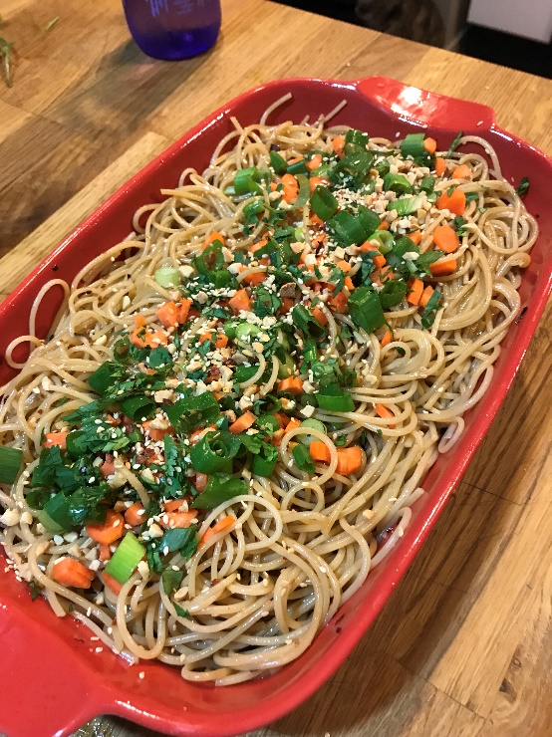
Serves 8-10
What you need:
- 1 good handful of linguine pasta
- 1 tbsp + 1/4 tsp Red pepper flakes
- 1/2 cup sesame oil
- 1 tsp chili paste
- 1/4 cup soya sauce
- 1 tbsp Honey
- Toppings:
  - Green onions, Chopped peanuts, Cilantro, Diced carrots, sesame seeds
  - Sriracha...for extra spice
*Tip: add more red pepper flakes or chili paste or dice up some Thai chilies as well for added heat



What you do:
- Drop your pasta into boiling salted water and cook to tender
- Heat the sesame oil and 1 tbsp of red pepper flakes over medium-high heat until it starts to sizzle. Remove from heat and let stand a few minutes
- Drain the Oil and toss the chili flakes
- on Medium heat add the Soya sauce, chili paste, and honey to the oil and mix well, it should start to thicken slightly
- Drain pasta and add hot noodles into your sauce and mix well
- Toss in a container and let cool while soaking in the sauce
When ready to eat, top with desired toppings listed and Enjoy!

