Quick & Easy Salmon Dinner

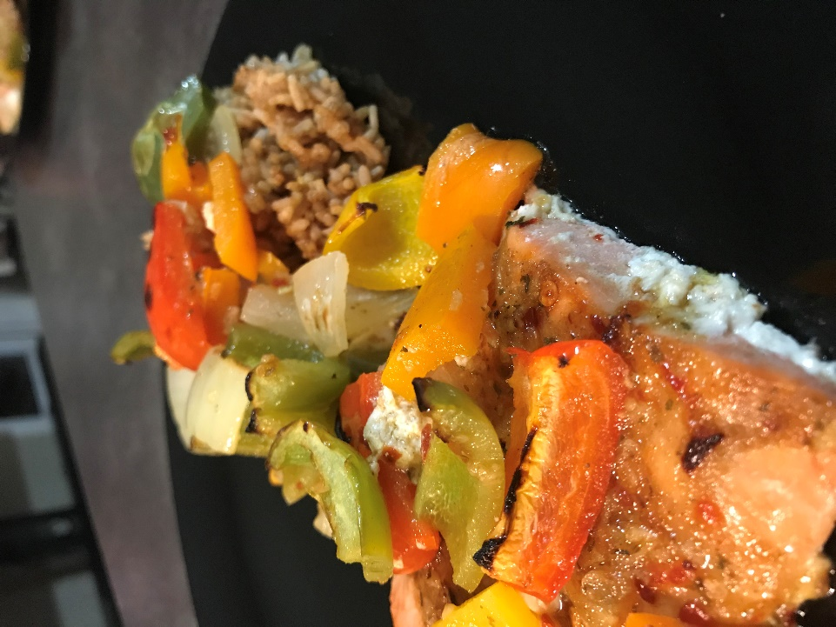
Here is what you need:
- 2 salmon Fillets
- 1/2 red pepper cut into chunks
- 1/2 green pepper cut into chunks
- 1/2 yellow pepper cut into chunks
- 1/2 orange pepper cut into chunks
(basically use 2 peppers of your choice)
- 1 small onion cut into chunks (white or purple works)
- My Salmon Marinade
  - Juice of one lime
  - 1/4 cup Extra Virgin Olive Oil
  - 2 tbsp of chopped cilantro or Parsley
  - 2 garlic cloves grated
  - 1 tsp red chili paste (1/2 tsp if you’re not big on Spicy)
  - 1 tsp cumin
  - 1 tbsp honey
  - pinch of salt and pepper
- 1/8 cup warm water
- pinch of chili flakes *optional
- Lime wedge *optional
Here is what to do:
- Preheat oven on Broil! you are going to cook this all very hot and very fast!
- Whisk together marinade ingredients until combined
- On a non-stick baking sheet place your salmon in the middle of the baking sheet and poor 3-4 tbsp of marinade over the salmon (do not use it all just yet!)
- Cut up veggies and place on both sides of the salmon and pour the marinade over the veggies (LEAVE 2 TBSP of marinade) and mix the veggies up good so everything gets coated
- add water just around the salmon to help cook the veggies
- Toss the tray into the oven on the middle rack and keep the oven closed for 10-12 minutes
- Take the salmon out and server immediately - use the remaining marinade over the salmon for an extra pop of flavour.
*optional sprinkle chili peppers and squeeze lime wedge over for more citrus taste over for a final finish
Serve over rice =)
(I used 5 minutes white rice mixed with 1 tsp soya sauce and 1 tsp hoisin sauce)
Serves: Dinner for Two
(double the marinade & veggies for 4 - 5 pieces of salmon dinner)



