Crock-pot Chilli

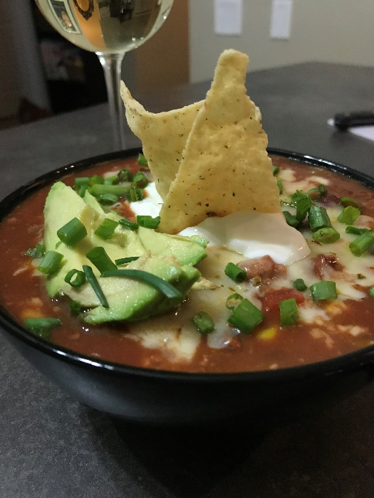
Here is what you need:
- crock-pot/slow cooker
- 1 pkg ground turkey or 2 boneless chicken breasts)
- 1 can black beans (rinsed a little and drained)
- 1 can kidney beans (rinsed a little and drained)
- 1 medium onion diced
- 3-4 fat cloves of garlic diced
- 1 cup diced peppers (green, red, orange, yellow - whatever you got! I used them all!)
- 1 cup frozen corn
- 1 can sliced whole tomatoes (you can used diced or crushed - I just like big chunks of tomato in mine)
- 1 can tomato sauce
- 1 large jalapeno pepper (or whatever spicy peppers you want) *optional
- 1 tsp cumin
- 1 & 1/2 tsp paprika (smoked if you got it)
- 1 & 1/2 tsp chili powder (use 1 tsp or less if you’re not into the spicy)
- 1 tsp dried or fresh oregano
- salt & pepper to taste
serve 6-10 servings
What you do:
- crock-pot gets turned on to low for 7-8 hours (no more then 10)
- cut up your onion and garlic - toss those into the getting hot crock-pot
- next goes canned tomatoes
- now add in your ground turkey or chicken breasts (rip it up a little as you are putting it in uncooked)
- add your tomato sauce and spices (including S&P)
- add in your canned beans, peppers and corn
- lastly goes in one whole jalapeno
- leave it alone for about 5-6 hours and then give it some love with a couple stirs and then let it go for the remaining couple hours
- once it is ready, get out the big ladle and remove that jalapeno and start scooping into bowls
- next is your choice... how you top this guy is on you :) my suggestions are above
Toppings (per serving):
- 1/4 cup Crushed Lime or Jalapeno Tortilla chips or leave them whole and spoon it on top
- 1 - 2 slices of lime
- dollop of sour cream (2 tsps or one big tbsp) *I also used light sour cream 5%
- 1/4 cup Jalapeno monterey jack cheese (or marble or cheddar whatever you desire)
- green onions
- diced Jalapeno or Pickled if that is your jam!
- 1/4 of a sliced avocado (avocado is a good sour cream sub and it is a healthy fat!)
- Hot Sauce (Green Habanero sauce if you want HOT)


