Coconut Shrimp Tacos

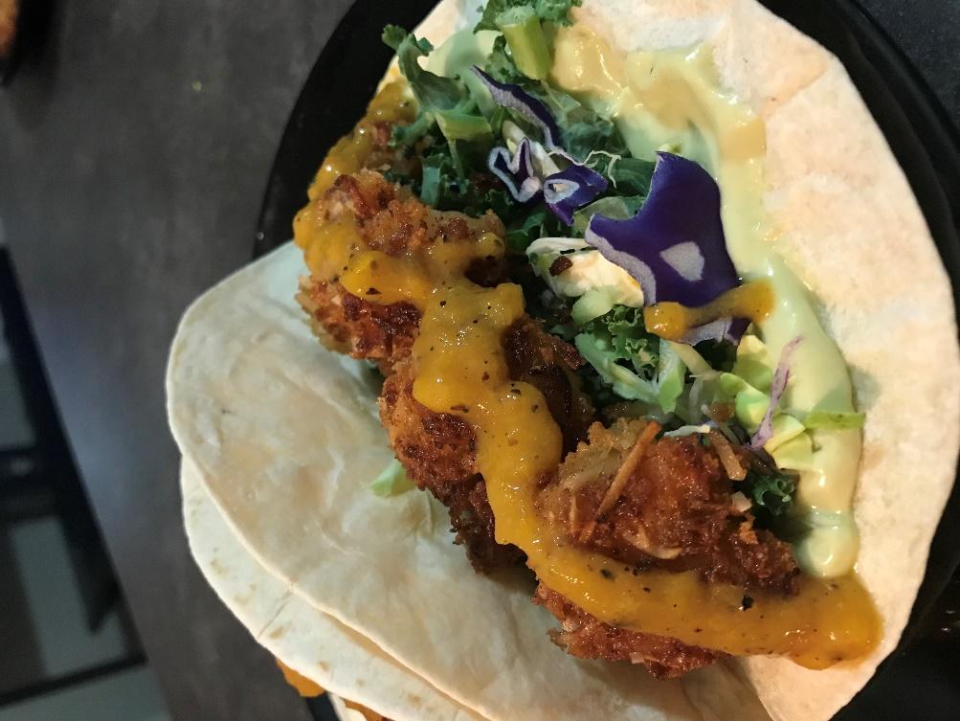
What you need:
- 1 300g bag frozen pre-cooked shrimp fairly thawed
- 1 1/4 cup panko crumbs
- 1 cup shredded sweetened coconut
- 1 tbsp paprika
- 1 tsp garlic powder
- 2 large eggs
- Salt & pepper
- 1/2 cup coconut oil
- 10 flour tortillas
- 1/2 package of Kale Slaw Mix
- Avocado Crema (Blend until smooth)
  - 1 avocado
  - 1/ 4 cup white onion (roasted if you make extra with sauce)
  - 1 fat roasted garlic clove
  - Juice of one lime
  - 1/2 cup sour cream
- Awesome Sauce
- Fresh Cilantro for garnish *Optional
What you do:
- Remove shells and de vein (if needed) your shrimp
- Mix panko crumbs, coconut, paprika and garlic powder in a bowl
*TIP - I get my hands right in there and massage the ingredients together - it breaks down that the panko crumbs and brings out the aromatics of the coconut
- In another bowl beat your eggs with a little S&P
- In a large skillet on high heat melt your coconut oil
- Get your breading station ready beside your stove, you are going to go:
  - Shrimp to egg - coat well
  - Eggy shrimp to panko mix and press evenly
  - From the panko into the hot oil skillet
- Cook shrimp until browned (do not move until your ready to flip to the other side) the second side will cook faster than the first so keep an eye that they don't burn
- remove fried shrimp to plate, and serve immediately
Serves about 8-10 tacos
* Tip - Keep the oven on broil after your done the sauce, so when you finish the shrimp you can toss the tortillas in the oven and get a nice little charred colouring to your tortillas... just do not leave the oven - these will take 30 seconds so make sure you stay in view, so you can get them out quick



