Awesome Sauce
(Roasted Habanero and Pineapple Mango Salsa)

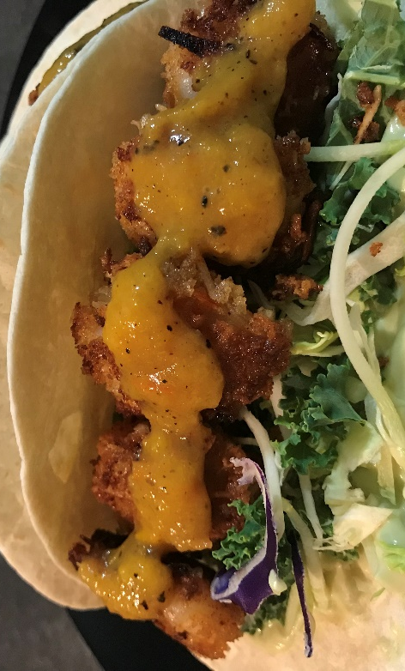

What you need:
- 1 cup mixed Frozen Mango & Pineapple (yes Frozen... I'll explain why later)
- 2 yellow bell peppers cut into chunks
- 3/4 cup rough chopped onion
- 6-8 roma grape tomatoes (seeds removed)
- 1 fat clove of garlic
- 2 habanero peppers seeded and cut in half
(wash your hands REALLY well after and or wear gloves... habanero has a lingering heat that can tingle a little)
- 2 tbsp Extra virgin olive oil
- Salt & pepper to taste *Optional
(I actually didn't add any because I'm watching my salt)
- 1/2 cup vegetable broth



What you do:
- Oven temp should be on Broil
- On a non-stick sheet pan toss your peppers, onions, garlic and habaneros in a little oil and S&P and broil for about 10-12 minutes
- Remove from oven and let cool a few minutes before removing some (not all) of the charred pepper skins (you want a little charred skin to enhance the deep smokey flavour in this sauce)
- In a blender (I used my magic bullet) combine the roasted veggies with the frozen mango, pineapple and the vegetable broth - combine until you have a smooth sauce consistency.
*TIP - The reason for frozen mango and pineapple is it helps with the structure of the sauce, you are going to get a smooth taste of both fruits, as well as it will help bring your sauce down in temperature quicker
- Place in a seal tight container and refrigerate until ready to use

