Bacon Cheeseburger Pizza

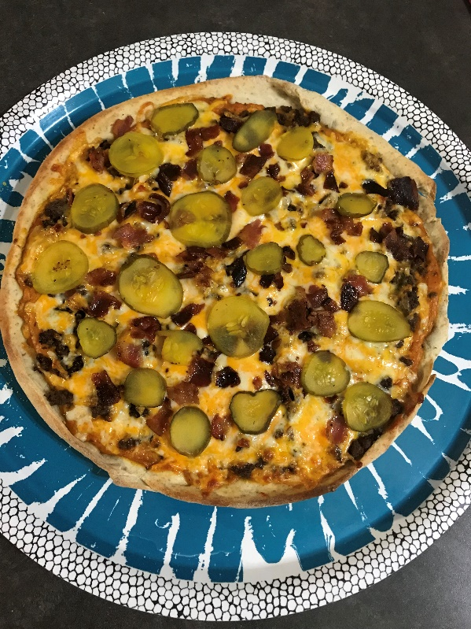
What you need:
- 1 pkg of pizza crust (or homemade dough - I did a whole wheat thin crust)
- 1/2-pound cooked ground beef (I used my skillet and cooked little mini burgers and then broke them up into chunks) *Leftover burgers from the night before would work too, just chop em up
- 6 strips of cooked Bacon
- 1/4 cup diced white onions
- sliced Pickles to your liking
- Burger Sauce:
  - 1/4 cup ketchup
  - 1/4 cup mustard
  - 1/2 cup mayo
  - 1/4 cup relish (I used my grandma's homemade stuff)
  - 1 tsp onion powder
  - 1 tsp paprika
  - 1 tsp garlic powder
  - Salt & Pepper to taste
- 1 & 1/2 cups Marble Cheese (you can use less or more and whatever cheese you want - Sharp Cheddar would be good)
- 1/8 cup cornmeal for the base (its important for a great crust)

What to do:
- preheat oven to 425 degrees
- roll out your dough to shape
- build your sauce and cut up any ingredients
- sprinkle your pizza pan or pizza stone with cornmeal
- place dough on the "cornmealed" pizza stone/pan
- next goes down your sauce (save a little for a few dollops)
- next goes the burger meat and onions
- now add the remaining dollops of sauce over the meat
- cheese, bacon and pickles go on to top the pizza
- cook for 12-15 minutes (could be 10-12 minutes on a pizza stone and all depends on your oven... you want a crispy edge and if you lift up the pizza you want it to be browned on the bottom and of course the cheese will be fully melted to perfection)
- let your pizza rest 3-5 minutes before cutting it *Get a decent pizza cutter, I promise its worth it!



