TACO SALAD

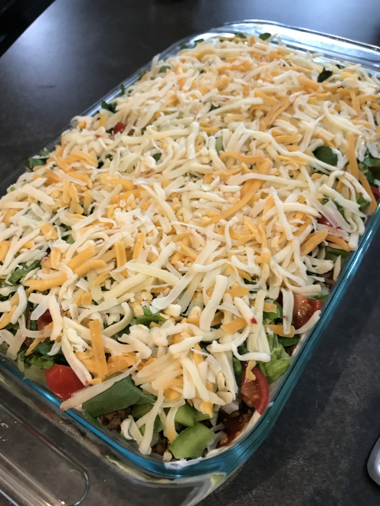
Here is what you need:
- 1 8oz package cream cheese
- 1/2 container sour cream
- 1 package of Taco seasoning
- 1 package of Extra lean ground beef
- 1 jar of Salsa (I used Hot and Chunky)
- 1 Large Green Pepper diced
- 1/2 large white onion diced
- 1 cup diced tomatoes (whatever you have – i used Cherry Tomatoes in this round)
- 1 cup shredded Romaine Lettuce
- 1 – 1 1/2 cups shredded Cheese (I used the Tex Mex mix from Crackle Barrel)
- 2 bags of Tortilla Chips
- 9 by 13 glass pan

What to do:
- Start by cooking your ground beef and seasoning it – you will want this slightly cooled when you add it to the pan
- mix your sour cream and cream cheese until combined – spread this on the bottom of your glass pan. this is the first layer – place in fridge until meat is cooler
- Once meat is cooled add the meat as layer 2
- salsa will go on top of the meat
- next would be your veggies – Tomatoes, Onions and Green pepper
- next is your layer of Lettuce
- and lastly is your Cheese layer
- Cover and let sit in the fridge an hour or more before serving
* the longer it sits the more things come together as one
Serve with Tortilla chips… scoops are okay but my suggestion is getting the Family style Lime, Corn or Jalapeno ones!! I used the Black bean and Garlic ones too – so yummy!



